

**PEACE TRACK MOBILE APPLICATION**

Product Requirements Document

# DOCUMENT CHANGE CONTROL

|  |  |  |  |
| --- | --- | --- | --- |
| **Version Number** | **Date of Issue** | **Author(s)** | **Brief Description of Change** |
| 0.1 | 4/7/2014 | M. McAllister | Initial document |
| 0.2 | 4/15/2014 | M. McAllister | Updated draft |
| 0.3 | 4/21/2014 | A. Knustsen | Edits |
| 0.4 | 4/21/2014 | M. McAllister | Incorporated edits |
|  |  |  |  |

# DEFINITION

|  |  |
| --- | --- |
| **Term** | **Definition** |
| PCV | Peace Corps Volunteer |
| RPCV | Returned Peace Corps Volunteer |
| PCMO | Peace Corps Medical Officer |
| VRF | Volunteer Report Form |
| VRT | Volunteer Reporting Tool |
| APCD | Associate Peace Corps Director (Interchangeable with PM) |
| PM | Program Manager (Interchangeable with APCD) |
| SI | Standard Sector Indicator |
| PDI | Post-Developed Indicator |

# PROJECT MANAGERS

**Patrick Choquette**

Director of the Office of Innovation

[pchoquette@peacecorps.gov](mailto:pchoquette@peacecorps.gov)

**Matthew McAllister**

Special Assistant, Office of Innovation

[mmcallister@peacecorps.gov](mailto:mmcallister@peacecorps.gov)

Contents

DOCUMENT CHANGE CONTROL 1

DEFINITION 1

PROJECT MANAGERS 1

BACKGROUND 2

Why Reporting Matters 2

Current Reporting Structure 2

Current Reporting Workflow 3

Desired Workflow 5

GITHUB ORGANIZATION: 6

FUNCTIONAL REQUIREMENTS: 6

Application Data Structure 7

DOWN THE ROAD IDEAS: 7

**PLATFORMS FOR DEVELOPMENT:**

iOS

Android

# BACKGROUND

## Why Reporting Matters

Peace Corps is held accountable for the work Volunteers conduct in the field. This work is reported by Volunteers through the Volunteer Report Form (VRF), which is created and captured through a web portal called the Volunteer Reporting Tool (VRT).

Data collection is vital to:

* Gauge the effectiveness of Volunteers and the programs they support.
* Determine the effectiveness of funds provided by other governmental agencies.
* Engender a sense of accomplishment among the Volunteers, who can look back at data collected after their service as evidence of their work.

## Current Reporting Structure

Peace Corps Volunteers (PCVs) are asked to report on the activities they are undertaking with their communities. The reporting prompts and data being tracked changes depending on the work the Volunteer is doing and the source of funding for the volunteer’s project. The current reporting structure from a Volunteer to Peace Corps for activities that contribute to Peace Corps Goal 1 starts at a top level Project Goal, with specific work Volunteers are doing being tracked by Indicators. Indicators are the ground level data points that measure Volunteers’ work.

***Project Goals****—*Project goal statements articulate intermediate or longer-term outcomes that need to occur to achieve the project’s purpose.

**e.g.** Community members will adopt behaviors to mitigate the harmful effects of HIV

***Project Objectives—***Project objectives articulate the most significant, attributable outcome or outcomes that will result from Volunteer and partner activities, and will contribute to achievement of project goals.

**e.g**. By XXXX, # males will have been circumcised and received post circumcision care.

***Activities:***Activity statements, one per objective, answer

1. How many Volunteers will conduct work corresponding to each objective,
2. Which set of activities they will undertake to achieve each project objective,
3. Major outputs of the activities (often number of people trained).

**e.g.** Each year, (#) of volunteers will increase awareness of HIV prevention through male circumcision by mobilizing X# of men to get circumcised through conducting a baseline and at least one of the following:

* trainings; workshops; referral services; health promotion campaigns; promotion to women's groups; other activities related to male circumcision.

***Indicators:*** Indicators are statistics or metrics used to gauge project performance (input, output, or outcome).

1. ***Outputs—***The direct result of project activities. Outputs relate to direct products or deliverables of project activities such as # of peer education sessions completed, number of people reached, and number of materials produced.

***e.g.*** *# of individuals reached with a message promoting male circumcision as a way to reduce the risk of HIV infection since the last reporting period*

1. ***Outcomes****—*Effect of project activities on target audience, such as change in knowledge, beliefs, skills, behaviors, and access to services. Projects typically have multiple, sequential outcomes: *“*short term outcomes” are any changes or benefits associated with changes in knowledge, skills, or attitudes; *“*intermediate outcomes,” are any changes in behaviors building upon the short-term outcomes; and *“*longer term outcomes,” or impacts, are longer range and cumulative effect of a project over time such as change in HIV infection, morbidity and mortality; impacts are rarely attributable to a single project. Note that these sequential levels of outcomes for capacity-building activities often match Kirkpatrick training evaluation levels.

***e.g.*** *# of males circumcised who returned at least once within 14 days of surgery for postoperative follow‐up care or after 7 days for non-surgical circumcision (intermediate-term outcome)*

## Current Reporting Workflow

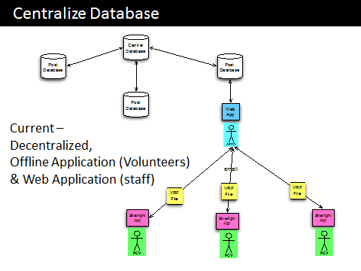

The current process involves the Volunteer downloading a Silverlight application on a desktop computer to view a Volunteer Report Form (VRF). The VRF is then emailed to the Associate Peace Corps Director (APCD). The APCD uploads the VRFs to the Post (Country) database, and then reviews the VRF to clean any applicable data and provide feedback to Volunteers on their reported work. That database then syncs with a central database.

* APCD/PM needs to create VRFs for each Volunteer in the web app
* APCD/PM then sends these VRFs to Volunteers.
* Volunteers must download Silverlight app onto a computer to open and access VRFs.
* After completing their VRFs Volunteers must attach VRF to email and send to APCD.
* APCD then must place VRFs in proper folder and import into the VRT.

Things go wrong. More pieces = more possible places for things to go wrong; requires more and challenging troubleshooting. The VRF is available offline, but only accessible on Windows and Mac; not accessible on iOS, Android, Windows Phone, or Linux.

Currently requires Internet access to download VRF application onto a computer to open the VRF file.

Peace Corps Volunteers (PCVs) currently use a 22-page long pen and paper-based "Activity and Outcome Tracking booklet" to keep track of their day-to-day activities in the field.

Examples of the type of data collected by Volunteers:

* Number of students taught in a class.
* Number of local leaders contacted.
* Number of participants at a movie screening.

The problem with tracking data on paper is that if the volunteer's tasks are outside or some distance from their homes (very common), and they forget to carry the paper with them, data for that day can be lost. As it happens, this is a very common occurrence and Volunteers often omit to record data meticulously, leading them to reconstruct data from memory (and thus creating inaccurate records).

This paper recording booklet is used by the Volunteer to fill out the Volunteer Report Form (VRF), using the online portal called the Volunteer Reporting Tool (VRT). Data is reported semi-annually (between two and four times per year), and frequently requires Volunteers to travel to a nearby city to complete their data entry. Data entry for the entire quarter can take many hours to complete.

## Desired Workflow

Peace Corps would like to reduce the steps to submitting Volunteer activity information and indicators. The agency would like to see a flatter reporting structure that allows for direct input by the end user, revision history on the database, and direct access by the staff and Volunteers to the information.

In the proposed diagram below, the Volunteers web app doesn’t necessarily need to be a web app that runs off a mobile browser. The web application simply represents the ability of the Volunteer to log into the reporting database directly to input their information. In many cases, it’s important that the Volunteer is able to record and save information about their work offline, and then upload that information later.

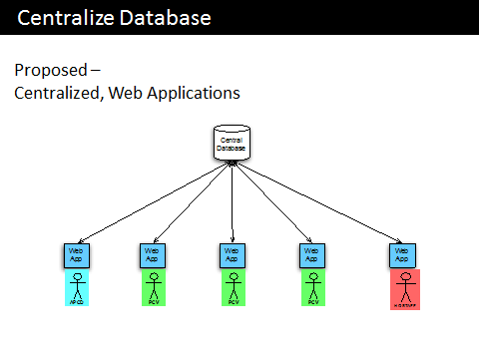

Introducing a mobile application into the process could:

* Reduce the number of steps in the data submission process.
* Ensure Volunteers record accurate data in a timely fashion since they are less likely to forget their phone or tablet compared to a large paper packet.
* Increase timeliness of information captured.
* Provide data more directly, with less intermediary tools.
* Allow the Volunteer to record their work electronically, even in an offline environment.

# GITHUB ORGANIZATION:

The PeaceTrack App will have an iOS and Android implementation. To support discussion on topics covering both environments there is a ReadMe repo as well. The ReadMe repo is purely for discussion on features common across platforms, it will not host code.

**README**: <https://github.com/PeaceCorps/peacetrack-readme>

**iOS**: <https://github.com/PeaceCorps/peacetrack-ios>

**Android**: <https://github.com/PeaceCorps/peacetrack-android>

# FUNCTIONAL REQUIREMENTS:

* User needs to record their activity and add data quickly. This is the most important priority.
* Activities should easily connect to upstream Objectives.
* Activities should easily connect to downstream Indicators (Standard Indicators comprised of Outputs and Outcomes, as well as Post-developed Indicators).
* The application data structure needs to be flexible enough so that when Peace Corps or affiliated organizations add/remove/change indicators, the application can adapt and treat legacy data in a non-destructive manner.
* Individual activities or reoccurring activities need to be able to connect to larger project frameworks and reporting hierarchies.
* Based on initial application set up, the user should provide basic information to the application that makes data entry easier, including Country and Sector. If a user enters the sector (Health, Education, …) the corresponding indicators will be filtered to ones that apply to that work.
* The application must be able to export the data collected in machine-readable and standard formats, including CSV.
* Data should be exportable both by Project and by Indicator. Users will be asked at the end of the day how many people were trained on X that were between the ages of Z and Y. Providing that data easily is important.
* When Volunteers work with the same people on multiple activities, the data structure needs to be flexible enough to be able to track results that may be observed outside of an activity – or after multiple activities.

## Application Data Structure

See PDF titled “Project Data Framework” for diagram of how the reporting structure is captured. See the excel file “Project Framework Indicator List” for the full list of indicators and how they are structured.

The element of the data structure to highlight is that the user only adds Activity information, and connects that activity to the corresponding Objectives (upstream), and the applicable indicators (downstream). If an Objective is selected, at least one indicator connected to that Objective must be added to measure the impact. Additional indicators not related to the specific Objective(s) can also be included.

As mentioned, the list of indicators and what they relate to can change over time. It’s important that the data structure allows for this flexibility.

# DOWN THE ROAD IDEAS:

* Direct sync and download ability to the main VRT database, without intermediary CSV export and import.
* Ability for Volunteers to see their aggregated effort to achieve their Project’s objectives
* Ability for Volunteers to report shared activities when they collaborate with other Volunteers
* Ability for Volunteers to see activities from Volunteers working in their community before them and, possibly, continue reporting on results achieved by the same participants